March Madness Win Prediction Using Efficiency
and Matchup Features
Cooper Tammen
Department of Computer Science
Kansas State University
cbtammen@ksu.edu
Abstract
This paper predicts NCAA tournament game outcomes using three classifiers: logistic regression, Random Forest, and XGBoost. Each game is represented as a difference vector with six features covering adjusted offensive and defensive efficiency, strength of schedule, seed gap, recent win percentage, and tournament round. I trained on 928 games from 2008 to 2022 and tested on 201 held-out games from 2023 to 2025. A simple ensemble averaging all three models' probabilities was also tested. XGBoost had the highest accuracy at 77.6%, but the ensemble had the best log-loss (0.481) and AUC (0.855). McNemar's test found no significant difference between any model pair (all p > 0.50). The accuracy gap between logistic regression and XGBoost is only two percentage points and is not statistically meaningful, suggesting the relationship between these features and outcomes is roughly linear. Calibration plots show predicted probabilities lining up well with actual win rates for all four models.

I. INTRODUCTION
Every March, 68 college basketball teams play 67 single-elimination games in the NCAA tournament. Millions of people fill out brackets, and almost nobody gets them right. Around 27% of games end in upsets, mostly from teams seeded 9 through 12, though every few years a 14 or 15 seed wins a game no one expected.
Most people pick brackets based on seed or name recognition. Seed is a decent shortcut in early rounds when top teams face bottom teams, but it stops working when the remaining teams are closer in quality. Adjusted efficiency metrics do a better job. They measure points scored and allowed per 100 possessions after correcting for opponent strength, giving a cleaner read on how good a team is. Dean Oliver introduced this possession-based approach in his work on basketball analytics [5].
In this project, I train machine learning classifiers on efficiency metrics to see if they can predict tournament games better than going off seed alone. Each matchup is encoded as a difference vector, and I test three models: logistic regression, Random Forest, and XGBoost, along with an ensemble that averages their predicted probabilities. I also evaluate probability calibration, since filling out a good bracket depends on having accurate win probabilities, not just picking the right side of each game.
This project falls under Track 5: Machine Learning & Probabilistic Models with methodological pillar OA (Applied AI Systems). I build a difference-vector encoding with symmetry properties, compare three classifiers using McNemar's test for significance, analyze probability calibration, and show that more complex models do not meaningfully outperform logistic regression on these features.
II. BACKGROUND AND RELATED WORK
Predicting NCAA tournament outcomes with machine learning has a growing body of work behind it, pushed along partly by Kaggle’s annual March Machine Learning Mania competition [6]. The competition scores predictions using log-loss, which rewards well-calibrated probability estimates over binary picks. This scoring choice has influenced how researchers in this space think about the problem.

Zimmermann et al. [2] ran one of the earlier systematic studies and found accuracy topping out around 74%. The more interesting result was that swapping feature sets produced bigger performance swings than swapping classifiers. In other words, what you feed the model matters more than which model you pick. That finding shaped my decision to spend most of my effort on feature selection and encoding rather than model architecture.

Levandoski and Lobo [1] tested seven classifiers (logistic regression, Random Forest, naïve Bayes, SVM, KNN, neural networks, and AdaBoost) using 57 box-score features encoded as difference vectors. A neural network hit 79% accuracy, but logistic regression had the best log-loss at 0.529. Their probability estimates were just more reliable. They also flagged KenPom offensive and defensive efficiency plus strength of schedule as features worth trying in future work. That is exactly what I use here, pulled from BartTorvik.

Yuan et al. [4] tried a mixture-of-modelers approach and found that regularized logistic regression beat more complex methods. Ensembles did not help. Lopez and Matthews [3] used logistic regression with efficiency metrics in the Kaggle competition and showed that a simple, well-specified model can hold its own against fancier approaches.

The efficiency metrics I use are grounded in Oliver’s [5] possession-based framework and his “Four Factors” of basketball success: effective field goal percentage, turnover rate, offensive rebounding percentage, and free throw rate. BartTorvik’s adjusted metrics (adjoe and adjde) build on this by correcting for opponent strength and game location, which lets you compare teams with different schedules and playing styles on the same scale.

My work differs from prior studies in three ways. I use BartTorvik’s adjusted efficiency metrics as primary features, which is what Levandoski and Lobo [1] recommended but did not implement. I apply McNemar’s test for formal significance testing between models, which none of the cited papers did. And I analyze probability calibration, which matters for anyone who wants to use these predictions to fill out a bracket.

III. METHODOLOGY
A. Data Sources and Collection
I used two data sources. From Kaggle’s March Machine Learning Mania 2026 competition [6], I pulled tournament results (MNCAATourneyCompactResults.csv), seeds (MNCAATourneySeeds.csv), regular-season game logs (MRegularSeasonCompactResults.csv), and team ID mappings (MTeams.csv, MTeamSpellings.csv). Kaggle covers every NCAA Division I tournament from 1985 forward; I filtered to 2008–2025. Seeds come encoded as strings like “W01” and needed to be parsed to numbers. Round was derived from the DayNum field using the tournament schedule.

From BartTorvik [7] I got season-level team statistics: adjusted offensive efficiency (adjoe), adjusted defensive efficiency (adjde), and strength of schedule (sos). These extend Oliver’s [5] possession-based framework by correcting for opponent strength and game location. I downloaded CSV files for each season from 2008 through 2025 using the URL pattern barttorvik.com/YYYY_team_results.csv. Each file has about 350–365 teams and 45 columns. I kept only team name, adjoe, adjde, and sos.

Merging the two sources was the hardest part of the data pipeline. BartTorvik uses team names (“Michigan”) while Kaggle uses numeric TeamIDs. I matched them through Kaggle’s MTeamSpellings.csv, but 15 teams still did not match due to abbreviation and punctuation differences. Those had to be fixed by hand. For the last-10-games win percentage, I sorted each team's regular season games by DayNum, grabbed the last 10 before the tournament started (conference tournament games can fall in that window), and calculated the win rate. The final dataset has 1,129 games across 17 seasons from 2008 to 2025, minus 2020 since the tournament was canceled. Labels split 564 vs. 565, almost exactly 50/50, which is what you would expect if the random A/B assignment is working correctly.

B. Feature Engineering
Each row in the dataset is a tournament matchup, not a single team. I encode team-quality features as differences: Team A’s value minus Team B’s value. For defensive efficiency, where lower is better, the subtraction is reversed (B minus A) so that a positive number always means Team A has the advantage. Seed gap works the same way: B’s seed minus A’s seed, since a lower seed number is better. Round is not differenced; it is just a contextual variable. Table I lists all six features.

TABLE I
FEATURE DEFINITIONS
Feature | Formula | Interpretation
delta_adjoe | A_adjoe − B_adjoe | + = A better offense
delta_adjde | B_adjde − A_adjde | + = A better defense
delta_sos | A_sos − B_sos | + = A harder schedule
seed_gap | B_seed − A_seed | + = A better seed
delta_win_pct | A_pct − B_pct | + = A won more (last 10)
round | 0–6 | Contextual (not diffed)

This encoding has a symmetry property: if you swap Team A and Team B, every feature sign flips and the label inverts. To avoid bias from always making the winner Team A, I randomized the A/B assignment for each game using numpy seed 42.

C. Classification Models
I tested three classifiers, all implemented in scikit-learn [8].

Logistic Regression (Baseline). This models the log-odds of Team A winning as a linear function of the feature differences. A difference vector is a natural fit for a linear model: the assumption is that your probability of winning scales linearly with how much better you are on each dimension. Features were standardized with StandardScaler in a Pipeline. I tuned the regularization parameter C over {0.01, 0.1, 1, 10, 100}.

Random Forest (Alternative 1). An ensemble of decision trees that can pick up nonlinear interactions logistic regression misses. For example, a seed gap of 8 might mean something different in the Round of 64 than in Elite Eight. Tuned parameters: n_estimators in {100, 200, 300}, max_depth in {3, 5, 7, None}, min_samples_split in {2, 5, 10}. No scaling needed.

XGBoost (Alternative 2). Gradient-boosted trees with built-in L1/L2 regularization. Generally, the strongest option for tabular data. Tuned parameters: n_estimators in {100, 200, 300}, max_depth in {3, 5, 7}, learning_rate in {0.01, 0.1, 0.2}, subsample in {0.8, 1.0}.

Ensemble (Probability Average). I averaged the predicted probabilities from all three models. No additional training. The idea was to see whether mixing diverse model families would improve calibration even if raw accuracy stayed flat.

D. Training and Validation
I used a temporal split: train on 2008–2022 (928 games, minus the canceled 2020 tournament), test on 2023–2025 (201 games). Within the training set, I ran season-grouped 5-fold cross-validation (GroupKFold with season as the group) for hyperparameter tuning via GridSearchCV, scored on negative log-loss. Grouping by season means no games from the same tournament appear in both the training and validation folds, which prevents leakage.

IV. EXPERIMENTS AND RESULTS
A. Evaluation Metrics
I used three metrics. Accuracy is the proportion of correctly predicted outcomes:

Accuracy = (TP + TN) / N

where TP and TN are correct predictions and N is the total number of test games. Log-loss (binary cross-entropy) penalizes confident wrong predictions:

L = −(1/N) Σ [yᵢ log(pᵢ) + (1−yᵢ) log(1−pᵢ)]

where yᵢ is the true label and pᵢ is the predicted probability. AUC (Area Under the ROC Curve) measures how well the model separates win from losses across all classification thresholds.

B. Hypothesis Testing
To check whether the accuracy differences between models are real or just noise, I defined:
H₀: There is no significant difference in classification accuracy between model pairs.

I tested this with McNemar’s test at α = 0.05. McNemar’s test compares paired classifiers on the same test set using a 2×2 contingency table of discordant predictions (games where one model got it right and the other got it wrong). The test statistic is:

χ² = (b − c)² / (b + c)
where b and c are the off-diagonal counts. Under H₀ this follows a chi-squared distribution with one degree of freedom.

C. Overall Model Comparison
TABLE II
OVERALL MODEL PERFORMANCE ON HELD-OUT TEST SET (2023–2025)
Model | Acc. | Log-L | AUC | p (vs Ens.)
Logistic Reg. | 0.756 | 0.494 | 0.846 | 1.000
Random Forest | 0.766 | 0.500 | 0.847 | 1.000
XGBoost | 0.776 | 0.485 | 0.853 | 0.505
Ensemble | 0.761 | 0.481 | 0.855 | —

Table II has the overall numbers. XGBoost wins on accuracy (77.6%), the ensemble wins on log-loss (0.481) and AUC (0.855). All four models land in the 74–79% accuracy range that Zimmermann et al. [2] and Levandoski and Lobo [1] also reported.
TABLE III
McNEMAR’S PAIRWISE TEST RESULTS (α = 0.05)
Model A | Model B | χ² | p-value | Reject H₀?
LR | RF | 0.042 | 0.838 | No
LR | XGBoost | 0.450 | 0.502 | No
RF | XGBoost | 0.125 | 0.724 | No
LR | Ensemble | 0.000 | 1.000 | No
RF | Ensemble | 0.000 | 1.000 | No
XGBoost | Ensemble | 0.444 | 0.505 | No

Table III tells the real story. Every McNemar p-value is above 0.50. I fail to reject H₀ in every case. None of these models is significantly better than any other. The two-point accuracy gap between logistic regression (75.6%) and XGBoost (77.6%) is not meaningful on 201 games. This lines up with what Zimmermann et al. [2] found about features mattering more than models, and with Yuan et al.’s [4] finding that ensembles do not reliably beat regularized logistic regression.

D. Calibration Analysis
Figure 1 is a reliability diagram comparing predicted probabilities to actual win rates. All four models track the diagonal reasonably well. When a model says 70% chance of winning, the team does win around 70% of the time. XGBoost and the ensemble hug the diagonal most tightly in the 0.4–0.7 range, while logistic regression wanders a bit between 0.6 and 0.85. The ensemble has the best log-loss (0.481) even though its raw accuracy is lower than XGBoost’s. Averaging probabilities from different model families smooths out individual miscalibration

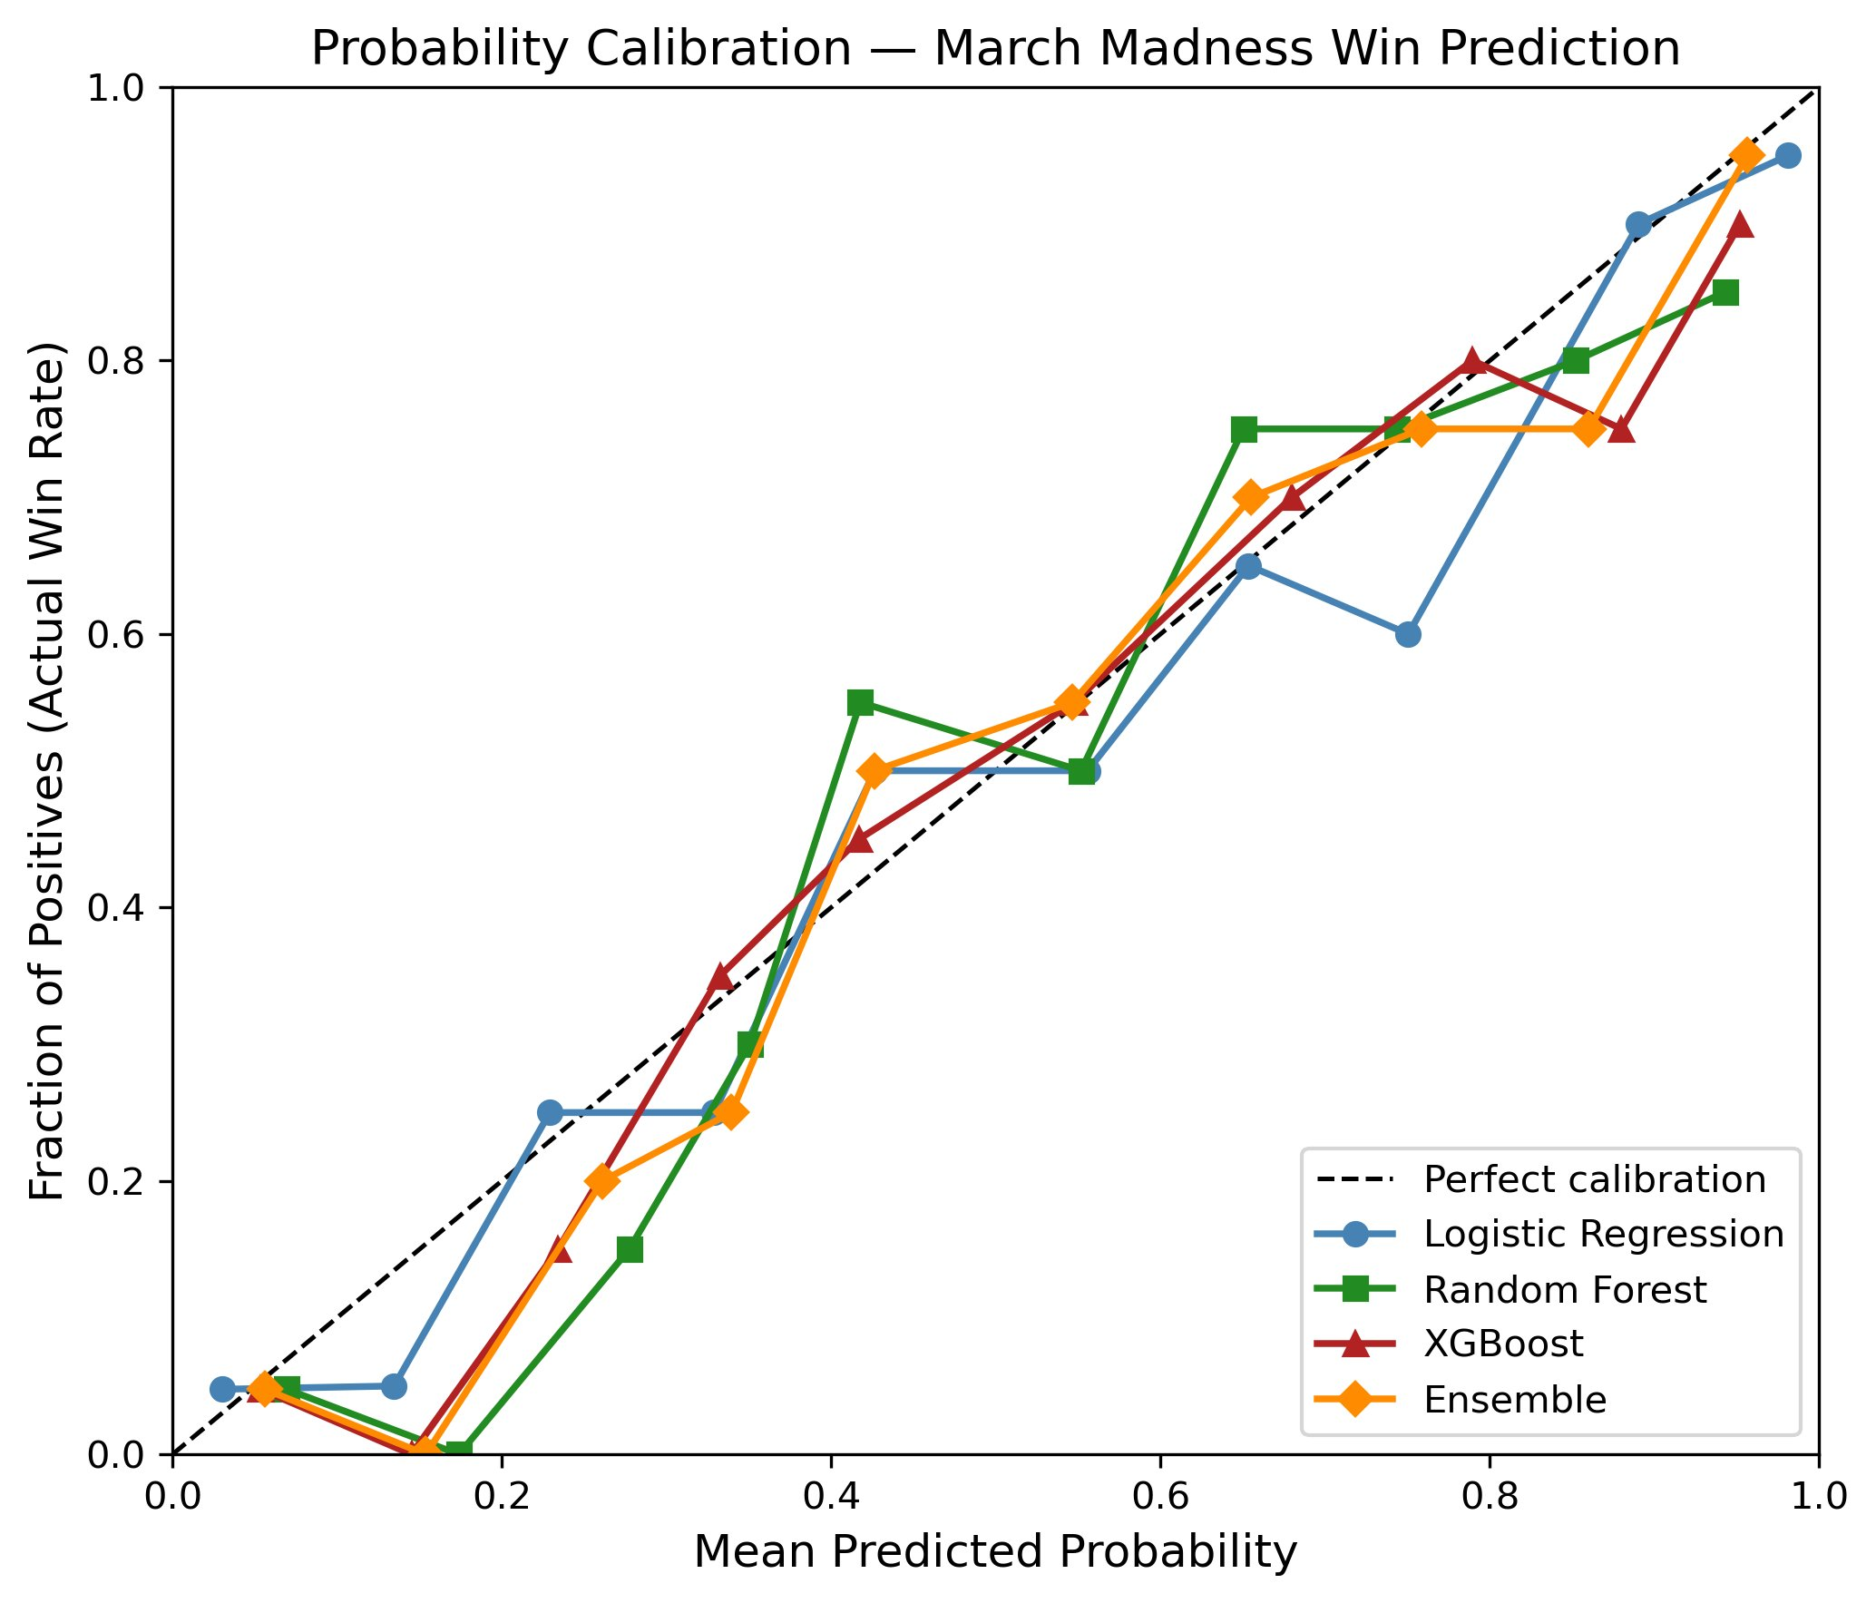
Fig. 1. Probability calibration for all four models on the 2023–2025 test set. Dashed line is perfect calibration.

E. Round-by-Round Analysis
TABLE IV
ACCURACY BY TOURNAMENT ROUND
Round | LR | RF | XGB | Ens. | N
Play-In | 75.0 | 58.3 | 75.0 | 58.3 | 12
Rd. of 64 | 77.1 | 81.3 | 79.2 | 77.1 | 96
Rd. of 32 | 79.2 | 81.3 | 83.3 | 85.4 | 48
Sweet 16 | 58.3 | 62.5 | 62.5 | 62.5 | 24
Elite 8 | 83.3 | 66.7 | 75.0 | 75.0 | 12
Final 4 | 83.3 | 83.3 | 83.3 | 83.3 | 6
Champ. | 66.7 | 66.7 | 66.7 | 66.7 | 3

Table IV breaks accuracy down by round. Early rounds go well (77–85% in the Round of 64 and Round of 32), which makes sense because the efficiency gaps are biggest there. The Sweet 16 is where everything falls apart. All models drop to 58–63%. By that point every remaining team is good, the feature differences shrink, and single-game variance takes over. A Sweet 16 matchup between a 1-seed and a 4-seed might have a 5-point efficiency gap, which is well within the noise of one basketball game. The Final Four and Championship numbers (83% and 67%) come from 6 and 3 games respectively, so do not read too much into them.

F. Season-by-Season and Feature Importance

TABLE V
ACCURACY BY SEASON
Season | LR | RF | XGB | Ens. | N
2023 | 68.7 | 68.7 | 70.1 | 70.1 | 67
2024 | 73.1 | 76.1 | 79.1 | 74.6 | 67
2025 | 85.1 | 85.1 | 83.6 | 83.6 | 67

Table V shows big year-to-year swings. The 2023 tournament was rough for every model (around 69–70%), while 2025 was easy (84–85%). Some years just have more upsets than others. Three tournaments are not a lot to draw conclusions from, and a different three-year window might tell a different story.

TABLE VI
FEATURE IMPORTANCE ACROSS MODELS
# | Feature | LR Coef. | RF Imp. | XGB Imp. | Avg.
1 | delta_adjoe | 1.514 | 0.283 | 0.257 | 0.278
2 | delta_adjde | 1.427 | 0.265 | 0.224 | 0.256
3 | delta_sos | 0.687 | 0.230 | 0.203 | 0.189
4 | seed_gap | −1.075 | 0.156 | 0.143 | 0.170
5 | delta_win_pct | 0.310 | 0.040 | 0.078 | 0.059
6 | round | −0.125 | 0.027 | 0.094 | 0.048

Table VI ranks features by importance. Offensive and defensive efficiency dominate, together accounting for over 50% of importance in both tree-based models. Strength of schedule and seed gap contribute a moderate amount. Last-10-games win percentage and round barely matter. Season-long quality metrics are doing most of the work here; recent momentum adds almost nothing. The negative logistic regression coefficient on seed_gap (−1.075) is consistent with the encoding: other features already capture team quality, so seed gap on its own provides a partially redundant signal that gets a negative weight once the more informative features are accounted for.

V. DISCUSSION AND CONCLUSION
A. Interpretation of Results
The main result is that model complexity does not help here. Logistic regression gets 75.6% accuracy, XGBoost gets 77.6%, and McNemar’s test says the difference is not significant (p = 0.502). The relationship between efficiency differences and game outcomes is roughly linear. The nonlinear interactions that tree-based models can capture do not add much on this feature set. Both Zimmermann et al. [2] and Yuan et al. [4] came to similar conclusions independently: the bottleneck is not the model; it is the features.

If you want better predictions, the path forward is better features, not fancier models. Adjusted offensive and defensive efficiency carry most of the signal. Last-10-games win percentage is basically noise at this point, probably because the efficiency metrics already incorporate the full season’s games.

The ensemble is an interesting case. It has the best log-loss and AUC despite lower accuracy than XGBoost. Averaging probabilities from three different model families smooths out the individual quirks of each one. For bracket filling, where you care about the quality of your probability estimates across all 63 games, not just the binary pick, better calibration matters more than a one-point accuracy edge.

B. Failure Modes
Every model drops to 58–63% accuracy in the Sweet 16. That is close to a coin flip. By that round, all remaining teams have already won two games and are among the strongest in their region. The efficiency differences that separate a 1-seed from a 16-seed (often 30 points of adjusted efficiency) shrink to maybe 5 points between a 1-seed and a 4-seed. Five points is well within the single-game variance in college basketball. Team-level aggregate stats cannot capture injuries, hot shooting nights, or strategic matchup advantages that matter more when the teams are this close.

Year-to-year variance is also large. Accuracy ranged from 69% in 2023 to 85% in 2025. The 2023 tournament had several lower-seeded teams making deep runs. A different three-year test window could give meaningfully different results.

C. Limitations
The test set is 201 games across three tournaments. That is small enough that even a 10-point accuracy difference could fail to reach significance, and the high McNemar p-values reflect limited statistical power as much as actual model equivalence. The feature set has only six team-level aggregate metrics; I did not include player-level data, tempo, distance to game site, or injury information. These gaps likely explain the accuracy ceiling.
The 2020 tournament cancellation leaves a gap in training data. The training set spans 14 years of basketball with rule changes during that period (the shot clock went from 35 to 30 seconds in 2015–16, the three-point line moved). BartTorvik’s metrics do not capture within-season improvement or roster changes. Conference tournament games included in the last-10 calculation may also add noise, since some teams rest starters in early conference tournament rounds.

D. Learning Reflections
The hardest part was the data merge. Fifteen teams did not match between BartTorvik and Kaggle and had to be fixed by hand. Getting the difference vector logic right also took more thought than I expected, especially reversing the defensive efficiency subtraction so that positive always means an advantage.

I learned the most about feature engineering. There are a lot of ways to represent the same data, and small choices like whether to encode matchups as raw features or as differences change everything downstream. I also gained an appreciation for how hard it is to build a model that meaningfully beats a simple baseline. That turned out to be one of the main findings.

If I started over, I would add player-level data and injury information instead of relying only on team-level stats. I would also try tempo as a feature since pace mismatches can swing games, and I would use a larger test set to get more statistical power out of the model comparisons.

E. Future Work
There are several things worth trying next: adding player-level stats, injury reports, and tempo as features; applying CalibratedClassifierCV to the tree-based models to improve their probability estimates; simulating full 68-team brackets and comparing the results against public bracket pools; extending the analysis to the women’s tournament using the same Kaggle dataset; and building a tool that generates real-time predictions during the live tournament.

F. Conclusion
I tested three classifiers and a simple ensemble on NCAA tournament prediction using efficiency-based difference vectors. Logistic regression, Random Forest, and XGBoost all land between 75.6% and 77.6% accuracy with no statistically significant differences (all McNemar p > 0.50). The ensemble has the best calibration despite not having the highest accuracy. Offensive and defensive efficiency are by far the most important features, while recent momentum and round barely register. Breaking through the ~75% accuracy ceiling will probably require player-level and game-specific features that team-level aggregates cannot provide.

REFERENCES
[1] A. Levandoski and J. Lobo, “Predicting the NCAA Men’s Basketball Tournament with Machine Learning,” CS 2750: Machine Learning, University of Pittsburgh, Apr. 2017.
[2] A. Zimmermann, S. Moorthy, and Z. Shi, “Predicting College Basketball Match Outcomes Using Machine Learning Techniques: Some Results and Lessons Learned,” CoRR, vol. abs/1310.3607, 2013.
[3] M. J. Lopez and G. J. Matthews, “Building an NCAA Men’s Basketball Predictive Model and Quantifying Its Success,” Journal of Quantitative Analysis in Sports, vol. 11, Jan. 2015.
[4] L.-H. Yuan, A. Liu, A. Yeh, et al., “A Mixture-of-Modelers Approach to Forecasting NCAA Tournament Outcomes,” Journal of Quantitative Analysis in Sports, vol. 11, Jan. 2015.
[5] D. Oliver, Basketball on Paper: Rules and Tools for Performance Analysis. Washington, D.C.: Brassey’s, Inc., 2002.
[6] Kaggle, “March Machine Learning Mania 2026.” [Online]. Available: https://www.kaggle.com/competitions/march-machine-learning-mania-2026/data
[7] BartTorvik, “College Basketball Team Statistics.” [Online]. Available: https://barttorvik.com
[8] F. Pedregosa et al., “Scikit-learn: Machine Learning in Python,” Journal of Machine Learning Research, vol. 12, pp. 2825–2830, 2011.

GenAI Audit Appendix
- Format Check Input: Review this word document outline. Does it adhere to standard IEEE/ACM double-column proceedings requirements? Flag any sections that exceed the 6–8-page structural norms.

Output:
Here's the full compliance review:
What passes:
- Double-column body text on pages 1-7
- Body content is ~7 pages (within 6-8 limit, excluding references and appendix)
- All required sections present (Abstract, Intro, Background, Methodology, Experiments, Discussion)
- Track 5 and OA pillar explicitly stated
- H₀ formally defined with McNemar's test and p-values
- Metrics defined mathematically (accuracy, log-loss, AUC formulas)
- Temporal holdout + season-grouped CV described
- 6 tables and 1 figure with captions
- 8 references in IEEE format

